**Homework 3**

Remember that your programs must read the data from the text files exactly as they appear. You may not edit the text files to make them more convenient for SAS. Turn in the code, log file and output. If any of these 3 items is missing then you will not be graded for that question. Use the snipping tool instead of screen shots and make sure the font is large enough for me to read.

1. Refer to the AIRPORTS dataset. Write a SAS program to read the data file from your diskette with an INFILE statement, store a permanent SAS dataset on your diskette, and print the dataset. There should be five variables (three character and two numeric) and 20 observations.

Code:

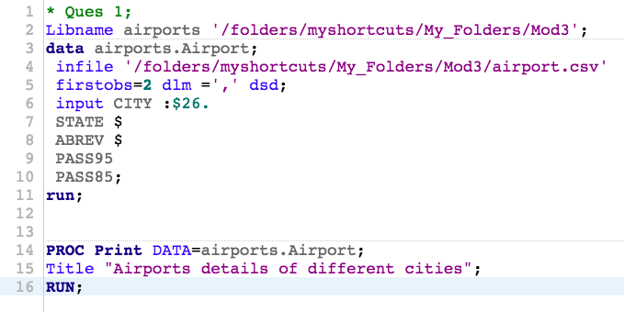

Log:

|  |
| --- |
| 1 OPTIONS NONOTES NOSTIMER NOSOURCE NOSYNTAXCHECK;  72  73 * Ques 1;  74 Libname airports '/folders/myshortcuts/My_Folders/Mod3';  NOTE: Libref AIRPORTS was successfully assigned as follows:  Engine: V9  Physical Name: /folders/myshortcuts/My_Folders/Mod3  75 data airports.Airport;  76 infile '/folders/myshortcuts/My_Folders/Mod3/airport.csv'  77 firstobs=2 dlm =',' dsd;  78 input CITY :$26.  79 STATE $  80 ABREV $  81 PASS95  82 PASS85;  83 run;    NOTE: The infile '/folders/myshortcuts/My_Folders/Mod3/airport.csv' is:  Filename=/folders/myshortcuts/My_Folders/Mod3/airport.csv,  Owner Name=root,Group Name=vboxsf,  Access Permission=-rwxrwx---,  Last Modified=26Feb2018:11:42:38,  File Size (bytes)=753    NOTE: 20 records were read from the infile '/folders/myshortcuts/My_Folders/Mod3/airport.csv'.  The minimum record length was 30.  The maximum record length was 52.  NOTE: The data set AIRPORTS.AIRPORT has 20 observations and 5 variables.  NOTE: DATA statement used (Total process time):  real time 0.03 seconds  cpu time 0.01 seconds      84  85  86 PROC Print DATA=airports.Airport;  87 Title "Airports details of different cities";  88 RUN;    NOTE: There were 20 observations read from the data set AIRPORTS.AIRPORT.  NOTE: PROCEDURE PRINT used (Total process time):  real time 0.10 seconds  cpu time 0.09 seconds      89  90 OPTIONS NONOTES NOSTIMER NOSOURCE NOSYNTAXCHECK;  103 |

Results:

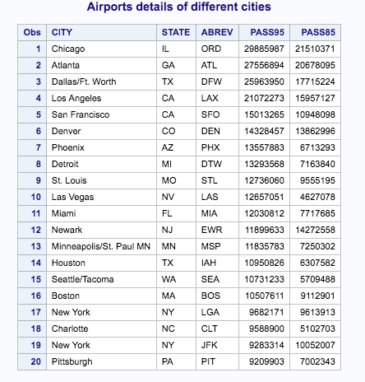

1. Refer to the RYAN dataset. Write a SAS program to read the data file from your USB with an INFILE statement and print the dataset. There should be four variables (one character and three numeric) and 21 observations.

Code:

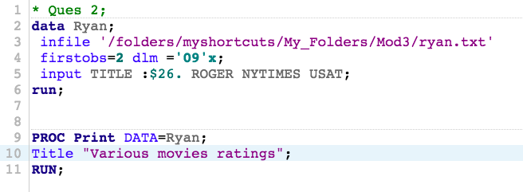

Log:

|  |
| --- |
| 1 OPTIONS NONOTES NOSTIMER NOSOURCE NOSYNTAXCHECK;  72  73 * Ques 2;  74 data Ryan;  75 infile '/folders/myshortcuts/My_Folders/Mod3/ryan.txt'  76 firstobs=2 dlm ='09'x;  77 input TITLE :$26. ROGER NYTIMES USAT;  78 run;    NOTE: The infile '/folders/myshortcuts/My_Folders/Mod3/ryan.txt' is:  Filename=/folders/myshortcuts/My_Folders/Mod3/ryan.txt,  Owner Name=root,Group Name=vboxsf,  Access Permission=-rwxrwx---,  Last Modified=26Feb2018:11:43:32,  File Size (bytes)=541    NOTE: 21 records were read from the infile '/folders/myshortcuts/My_Folders/Mod3/ryan.txt'.  The minimum record length was 13.  The maximum record length was 32.  NOTE: The data set WORK.RYAN has 21 observations and 4 variables.  NOTE: DATA statement used (Total process time):  real time 0.01 seconds  cpu time 0.01 seconds      79  80  81 PROC Print DATA=Ryan;  82 Title "Various movies ratings";  83 RUN;    NOTE: There were 21 observations read from the data set WORK.RYAN.  NOTE: PROCEDURE PRINT used (Total process time):  real time 0.07 seconds  cpu time 0.07 seconds      84  85 OPTIONS NONOTES NOSTIMER NOSOURCE NOSYNTAXCHECK;  98 |

Results:

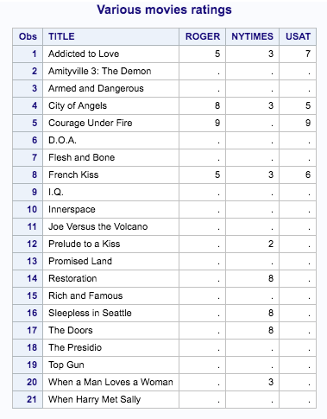

1. Refer to the HOCKEY dataset. Write a SAS program to read the data file from your USB with an INFILE statement and print dataset. Combine the month, day, and year into one variable representing the date. There should be six variables (three character and three numeric) and 36 observations.

Code:

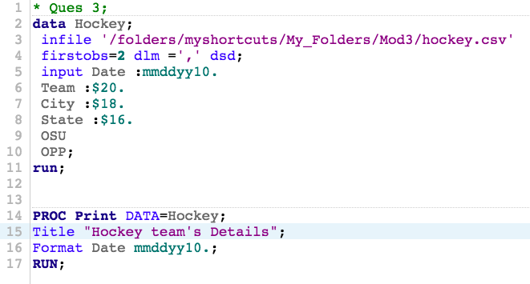

Log:

|  |
| --- |
| 1 OPTIONS NONOTES NOSTIMER NOSOURCE NOSYNTAXCHECK;  72  73 * Ques 3;  74 data Hockey;  75 infile '/folders/myshortcuts/My_Folders/Mod3/hockey.csv'  76 firstobs=2 dlm =',' dsd;  77 input Date :mmddyy10.  78 Team :$20.  79 City :$18.  80 State :$16.  81 OSU  82 OPP;  83 run;    NOTE: The infile '/folders/myshortcuts/My_Folders/Mod3/hockey.csv' is:  Filename=/folders/myshortcuts/My_Folders/Mod3/hockey.csv,  Owner Name=root,Group Name=vboxsf,  Access Permission=-rwxrwx---,  Last Modified=26Feb2018:11:43:23,  File Size (bytes)=1701    NOTE: 36 records were read from the infile '/folders/myshortcuts/My_Folders/Mod3/hockey.csv'.  The minimum record length was 35.  The maximum record length was 56.  NOTE: The data set WORK.HOCKEY has 36 observations and 6 variables.  NOTE: DATA statement used (Total process time):  real time 0.01 seconds  cpu time 0.01 seconds      84  85  86 PROC Print DATA=Hockey;  87 Title "Hockey team's Details";  88 Format Date mmddyy10.;  89 RUN;    NOTE: There were 36 observations read from the data set WORK.HOCKEY.  NOTE: PROCEDURE PRINT used (Total process time):  real time 0.11 seconds  cpu time 0.11 seconds      90  91 OPTIONS NONOTES NOSTIMER NOSOURCE NOSYNTAXCHECK;  104 |

Results:

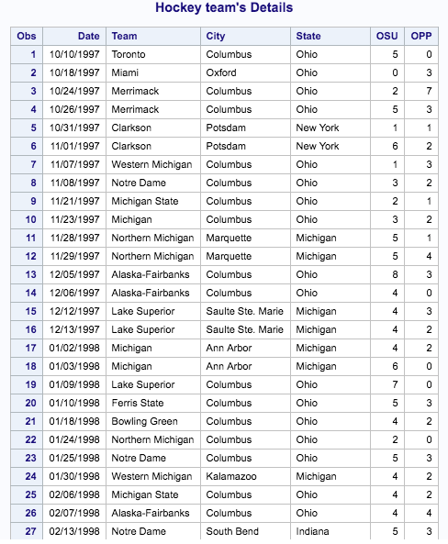

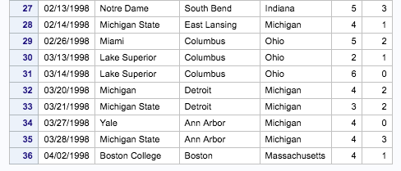

1. Refer to the LIMES dataset. Write a SAS program to read the data file from your USB with an INFILE statement and print dataset. Combine the month, day, and year into one variable representing the date.

Code:

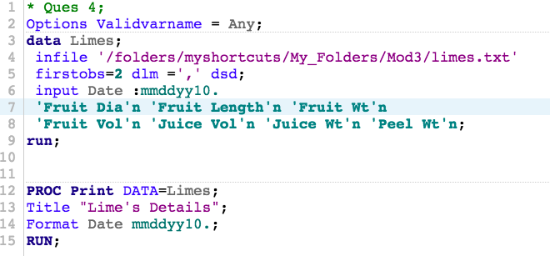

Log:

|  |
| --- |
| 1 OPTIONS NONOTES NOSTIMER NOSOURCE NOSYNTAXCHECK;  72  73 * Ques 4;  74 Options Validvarname = Any;  75 data Limes;  76 infile '/folders/myshortcuts/My_Folders/Mod3/limes.txt'  77 firstobs=2 dlm =',' dsd;  78 input Date :mmddyy10.  79 'Fruit Dia'n 'Fruit Length'n 'Fruit Wt'n  80 'Fruit Vol'n 'Juice Vol'n 'Juice Wt'n 'Peel Wt'n;  81 run;    NOTE: The infile '/folders/myshortcuts/My_Folders/Mod3/limes.txt' is:  Filename=/folders/myshortcuts/My_Folders/Mod3/limes.txt,  Owner Name=root,Group Name=vboxsf,  Access Permission=-rwxrwx---,  Last Modified=26Feb2018:11:43:39,  File Size (bytes)=4031    NOTE: 100 records were read from the infile '/folders/myshortcuts/My_Folders/Mod3/limes.txt'.  The minimum record length was 29.  The maximum record length was 42.  NOTE: The data set WORK.LIMES has 100 observations and 8 variables.  NOTE: DATA statement used (Total process time):  real time 0.01 seconds  cpu time 0.00 seconds      82  83  84 PROC Print DATA=Limes;  85 Title "Lime's Details";  86 Format Date mmddyy10.;  87 RUN;    NOTE: There were 100 observations read from the data set WORK.LIMES.  NOTE: PROCEDURE PRINT used (Total process time):  real time 0.28 seconds  cpu time 0.28 seconds      88  89 OPTIONS NONOTES NOSTIMER NOSOURCE NOSYNTAXCHECK;  102 |

Results:

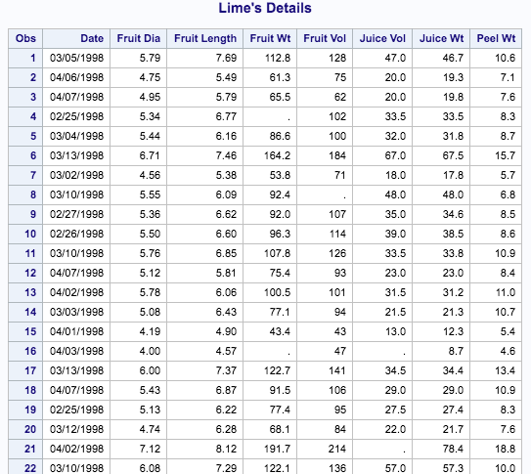

1. Refer to the HANKS dataset. Write a SAS program to read the data file from your USB with an INFILE statement and print the dataset. There should be 11 variables (two character and nine numeric) and 22 observations. (HINT: use DSD option)

Code:

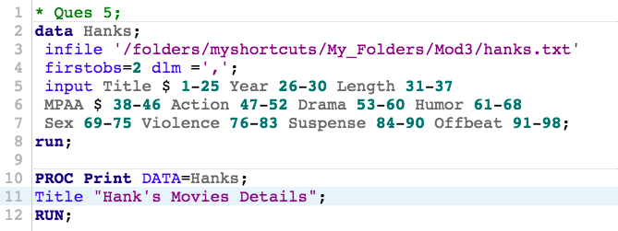

Log:

|  |
| --- |
| 1 OPTIONS NONOTES NOSTIMER NOSOURCE NOSYNTAXCHECK;  72  73 * Ques 5;  74 data Hanks;  75 infile '/folders/myshortcuts/My_Folders/Mod3/hanks.txt'  76 firstobs=2 dlm =',';  77 input Title $ 1-25 Year 26-30 Length 31-37  78 MPAA $ 38-46 Action 47-52 Drama 53-60 Humor 61-68  79 Sex 69-75 Violence 76-83 Suspense 84-90 Offbeat 91-98;  80 run;    NOTE: The infile '/folders/myshortcuts/My_Folders/Mod3/hanks.txt' is:  Filename=/folders/myshortcuts/My_Folders/Mod3/hanks.txt,  Owner Name=root,Group Name=vboxsf,  Access Permission=-rwxrwx---,  Last Modified=26Feb2018:11:42:51,  File Size (bytes)=2283    NOTE: 22 records were read from the infile '/folders/myshortcuts/My_Folders/Mod3/hanks.txt'.  The minimum record length was 98.  The maximum record length was 98.  NOTE: The data set WORK.HANKS has 22 observations and 11 variables.  NOTE: DATA statement used (Total process time):  real time 0.01 seconds  cpu time 0.02 seconds      81  82 PROC Print DATA=Hanks;  83 Title "Hank's Movies Details";  84 RUN;    NOTE: There were 22 observations read from the data set WORK.HANKS.  NOTE: PROCEDURE PRINT used (Total process time):  real time 0.13 seconds  cpu time 0.12 seconds      85  86 OPTIONS NONOTES NOSTIMER NOSOURCE NOSYNTAXCHECK;  99 |

Results:

